Is Prison Obsolete Conference Presentation
Sisters Inside Carolyn Craig
Brisbane, October 9th, 2014 The Gendered Experience in Custody

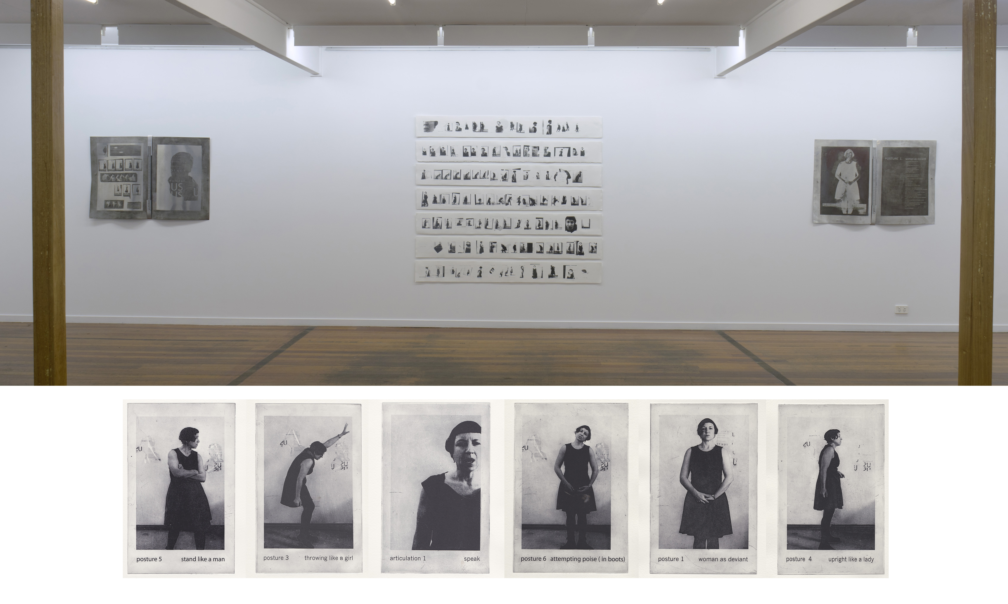

The Drowning Moment that Never ends (Inertia as Social Training from Birth)

Research that records custodial experience usually takes the form of data or interviews framed within academic parameters. These studies classify our lived experience through an objectifying gaze. Even in the most humanistic study, the very statistical modeling that validates it within academia eradicates our visibility as subjects and continues to validate the penal gaze of the panopticon.
As women we are even less visible. The experience of criminality permanently incorporates us within a process of social erasure and dismissal .We become victims of a pervasive carceral logic that extends beyond the perimeter of the prison itself.
Prison becomes an extension of state and social apparatus that have inscribed Otherness and trauma upon our bodies. As female offenders we are statistically drawn from (Davidson 2009) histories of abuse, neglect, physical deprivation and mental and drug abuse issues.
My art practice makes the lived experience of prison visible in a form of practice led research focusing on broader issues of gender and power within society.
This broader approach is necessary as the prison structure “incorporates and amplifies all the anti social modes of control that oppress women outside the prison.” (Carlen 1998).
Since my release day in 2003 I have felt the constant sense that another’s hands were on my body. I felt (I feel) surveilled, vulnerable, abused. The thread of the penal gaze had been effectively internalised as Michel Foucault (1974, 1975,1979) and Jeremy Bentham (1791) theorised.
I made prints that expressed the felt claustrophobia of custodies enterprises. The saturated blacks of the linocut medium allowed me to articulate the dark recesses of the felt space of mental incarceration (Figure 1 and 2), to visualize the haptic sense of the states’ apparatus on my body. An understanding came upon me that this haptic knowledge was a reflection of an ongoing process of Othering. Custody had merely amplified it.
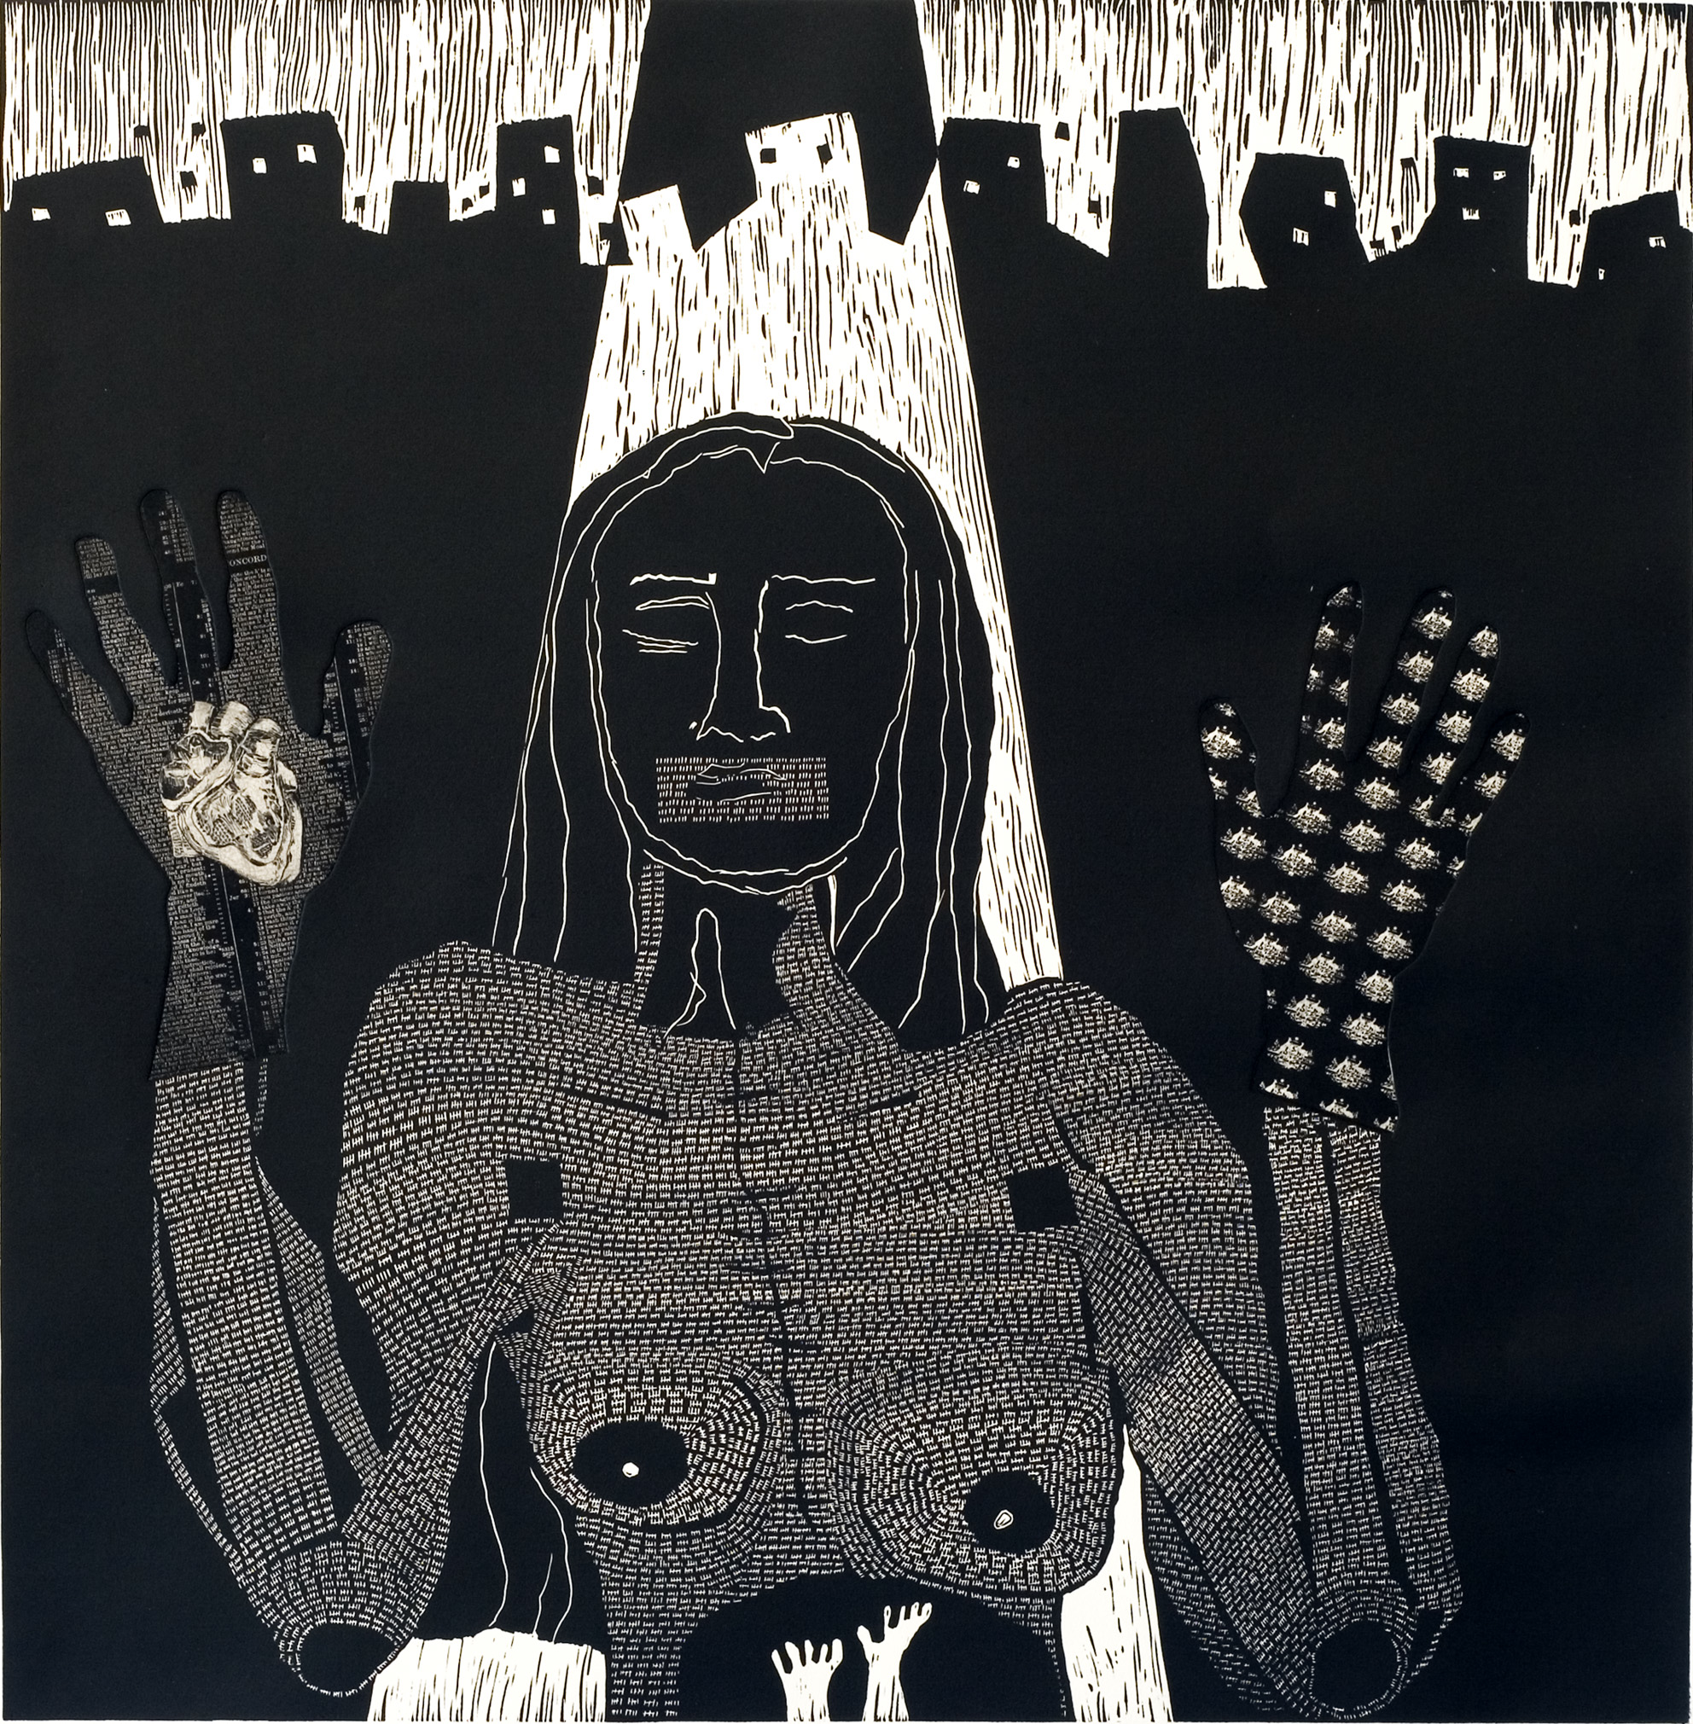
Figure 1: Carolyn Craig I Surrender 2009 Linocut and etchings, 70cmby 60cm
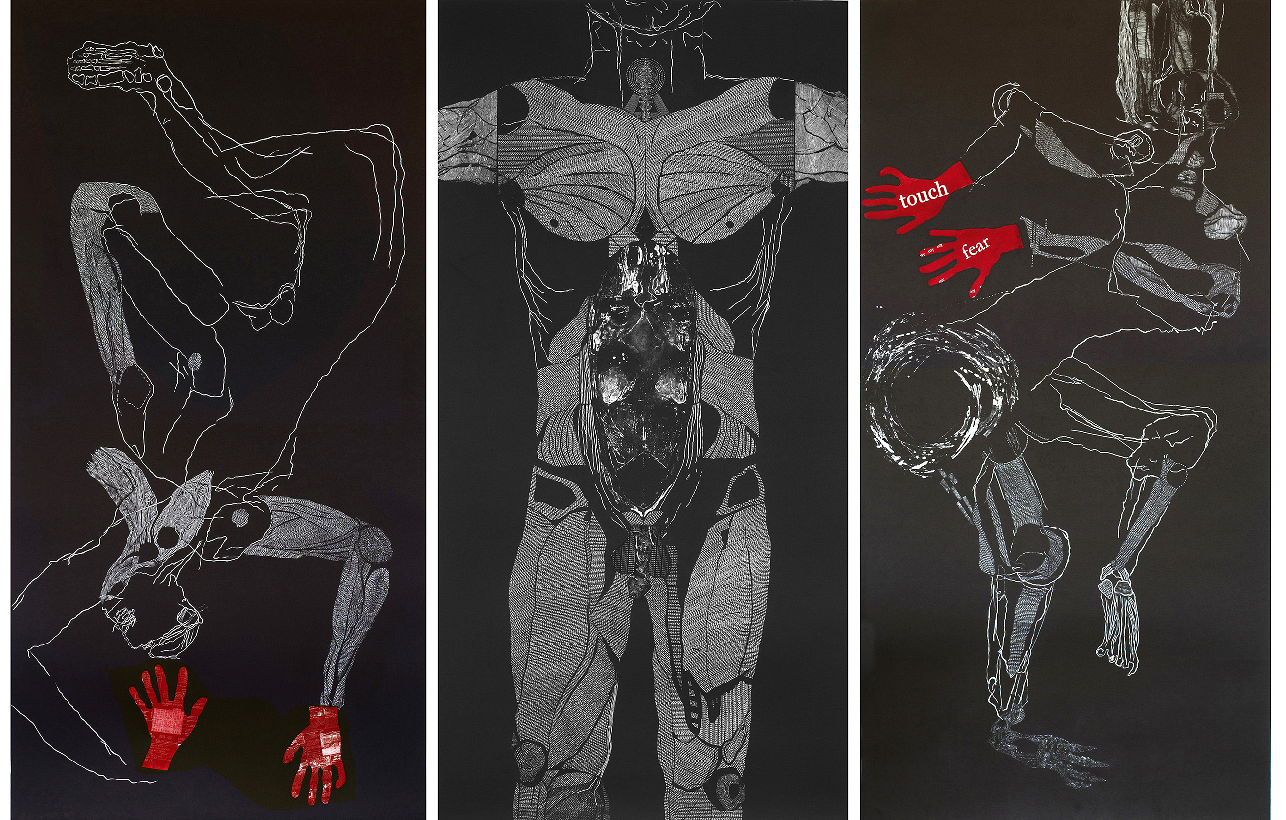
Figure 2: Carolyn Craig Dante’s Descent 2013 etchings and Linocuts, 3 panels, each 195 cm by 105 cm.

A survey of current theorists such as Eileen Bowdry (1997,2009) , Pat Carlen (1983,2002,2005) and Judith Butler (1988) provided an affirmation from researchers that “ imprisonment comprises a discrete component of the structural social controls and inequalities experienced by imprisoned populations within the free community “ (Carlton and Segrave 2011).
Prison accentuates the coercive systems that pervasively act upon the female body. Its systems and schemes are microcosms of the systems and schemes in broader society.
To some extent a study of penality is a study of power and how our current legal and moral frameworks operate upon the most disenfranchised members in society. Prison articulates these regimes of control in their true brutality (and banality). This brutality is not always violence. Consider the erasure of subjective presence, and the permanent inscription of Otherness. Carceral regimes deny the
Integrity of the body; obfuscate basic physical needs and silence spirit and desire. The structural Othering integral to its functioning often mimics the abuse many of us suffered in our childhoods and domestic relationships and corners us into regimented behaviours of inertia and dependence.
In my art practice I have examined this panoptic gaze and attempted to reclaim control of my subjectivity through a daily ritual of self-portraiture. This daily drawing process mimics the counting of days in custody but attempts to subvert that same archiving of my flesh by erasing the inscriptive carceral processes and re inscribing new subjective parameters with each mark and gestural act of the charcoal. The initial series of this work that lasted two years was drawn over sheets of the daily edition of the Australian Newspaper (Figure 3).
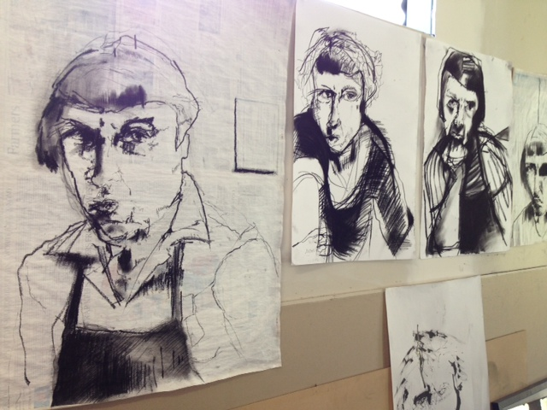
Figure 3: Carolyn Craig Daily Surveillance Drawings- Works in Progress Image 2013, newspaper, charcoal, dimensions variable.

The newsprint represented the daily indexical nature of custody and the scarcity of materials available. It also reflected the normalizing gaze of mainstream media and their impact on all our custodial sentences. The second series of drawings now incorporates text in order to subvert the social inscriptive processes and elucidate a subjective self-free from control and constraints (Figure 4).

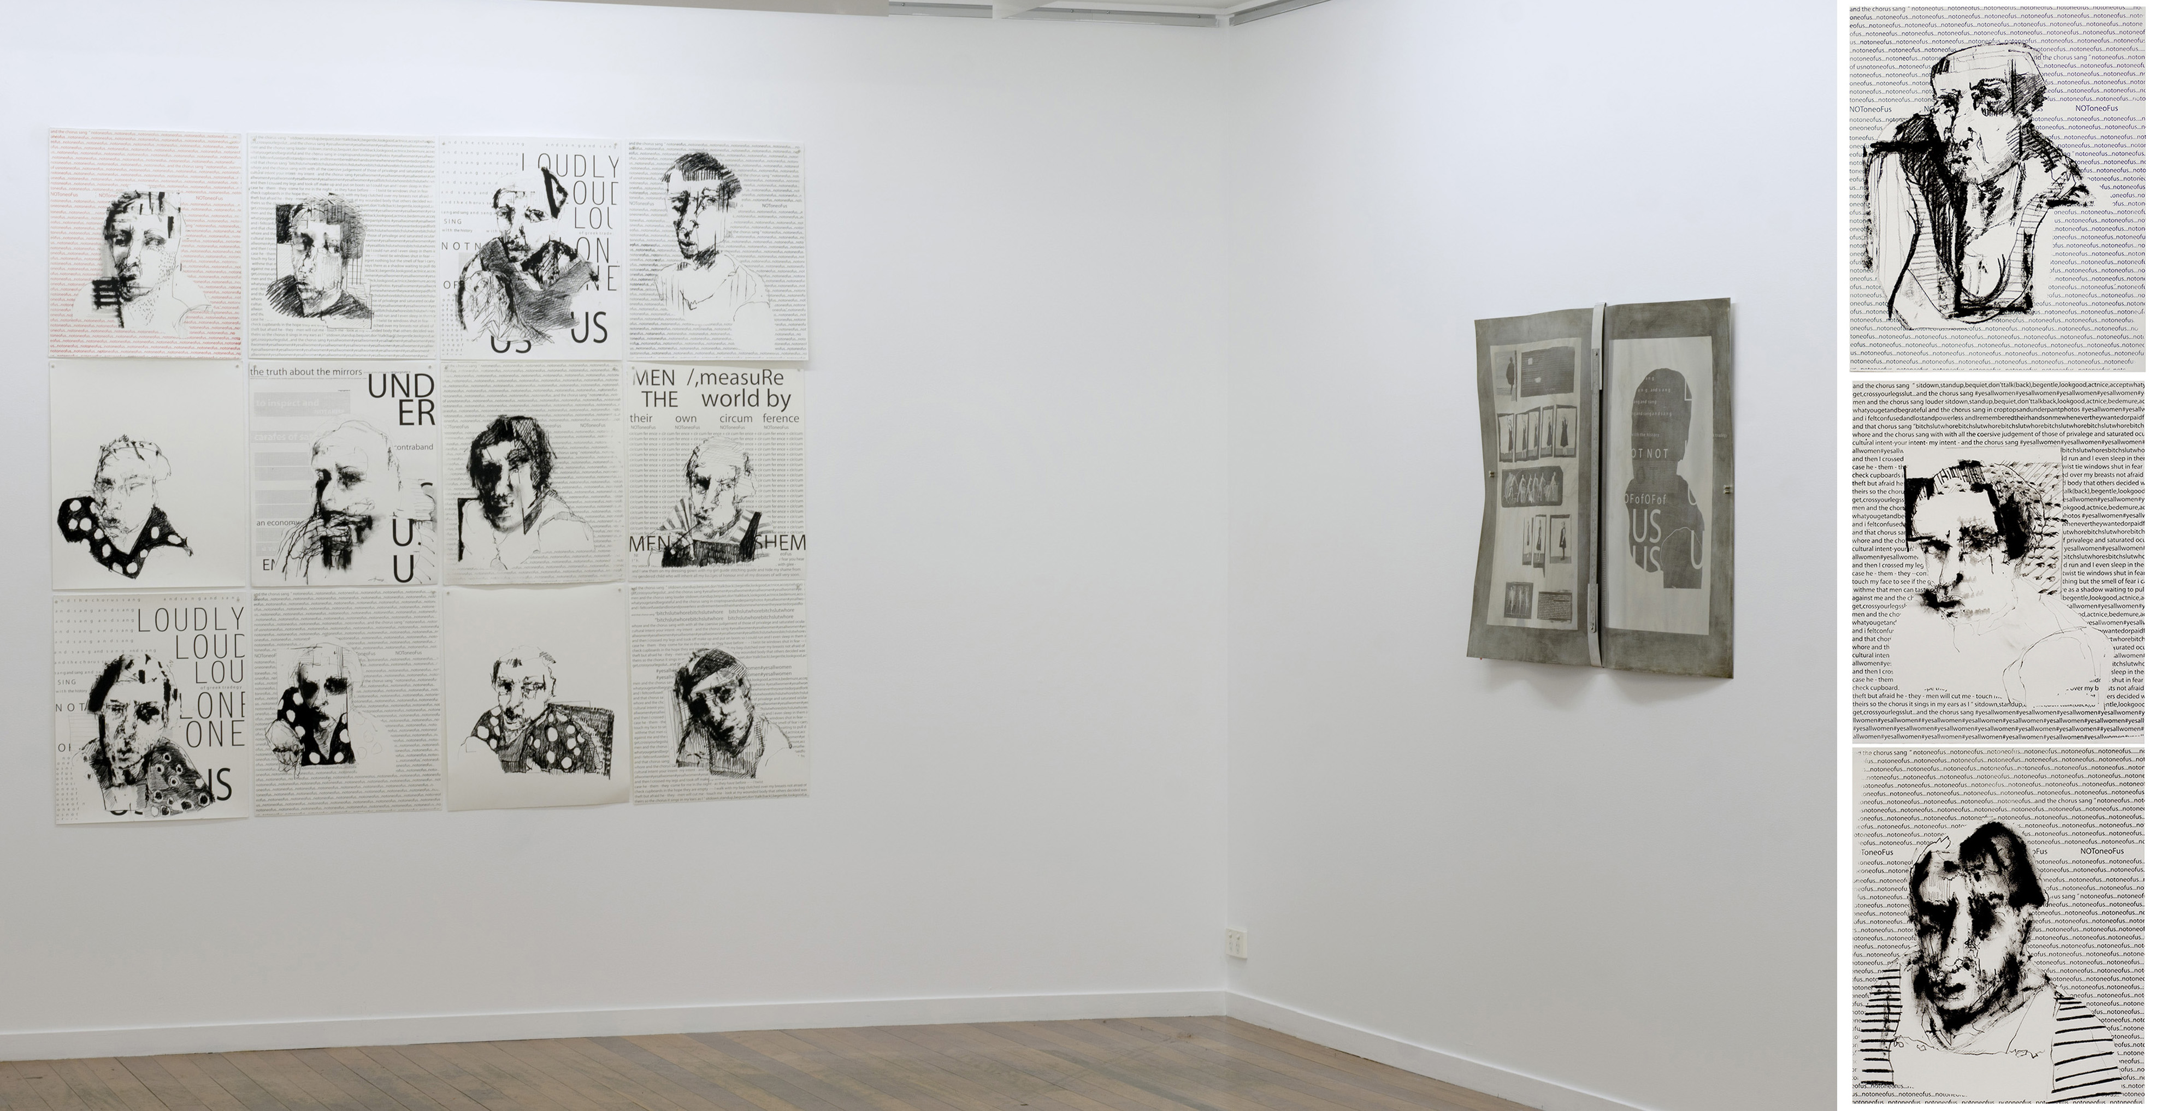Figure 4: Carolyn Craig Self Surveillance images 2014, charcoal, ink, screen-printed text, install photograph from The Hold Artspace, Brisbane.

The construction of a new subjectivity is an attempt to sever the armature of the state from unfettered authorship over me.
Consideration of the gaze led me to research ideas of objectification theory. Objectification theory considers the female body as the observed body of the male gaze. When considering the nature of society as inherently patriarchal this male gaze is not restricted to the biological watchfulness of a male but is in fact an instrumental feature of the coercive scaffolding of society.
This gaze is an active gaze that extends to the felt touch. It has been examined by previous artists such as Lorna Simpson in Guarded Conditions (1989, Figure 5) and Marina Ambramovic in Rthymn O (1974, Figure 6).
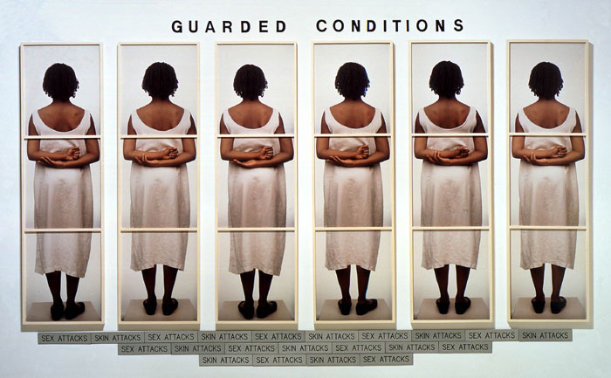
Figure 5: Lorna Simpson Guarded Conditions 1989 , Poloroid Photos, 231cm by 333cm

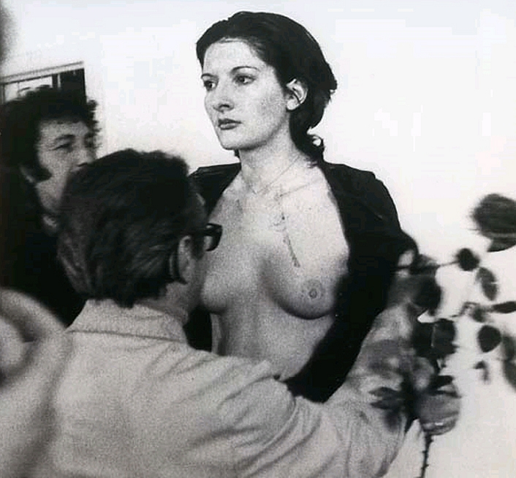
Figure 6:Marina Abramovic, Rhythm O 1974 , Performance still

Pivotal to my understanding of objectification is the article “ That Swimsuit Becomes You: Sex Difference in Self-Objectification, Restraint Eating and Math Performance “ (Fredrickson et al 1998: Figure 7). This study evaluated female gendered subjects performance whilst undertaking a series of math’s questions one whilst clothed, and then again whilst in swimwear. The female subjects performed consistently lower whilst wearing bathers. The male subjects expressed no negative bodily feedback as of result of wearing a swimsuit and did not record lower results than when clothed. This indicates a socially inscribed discomfort in our own female gendered bodies.
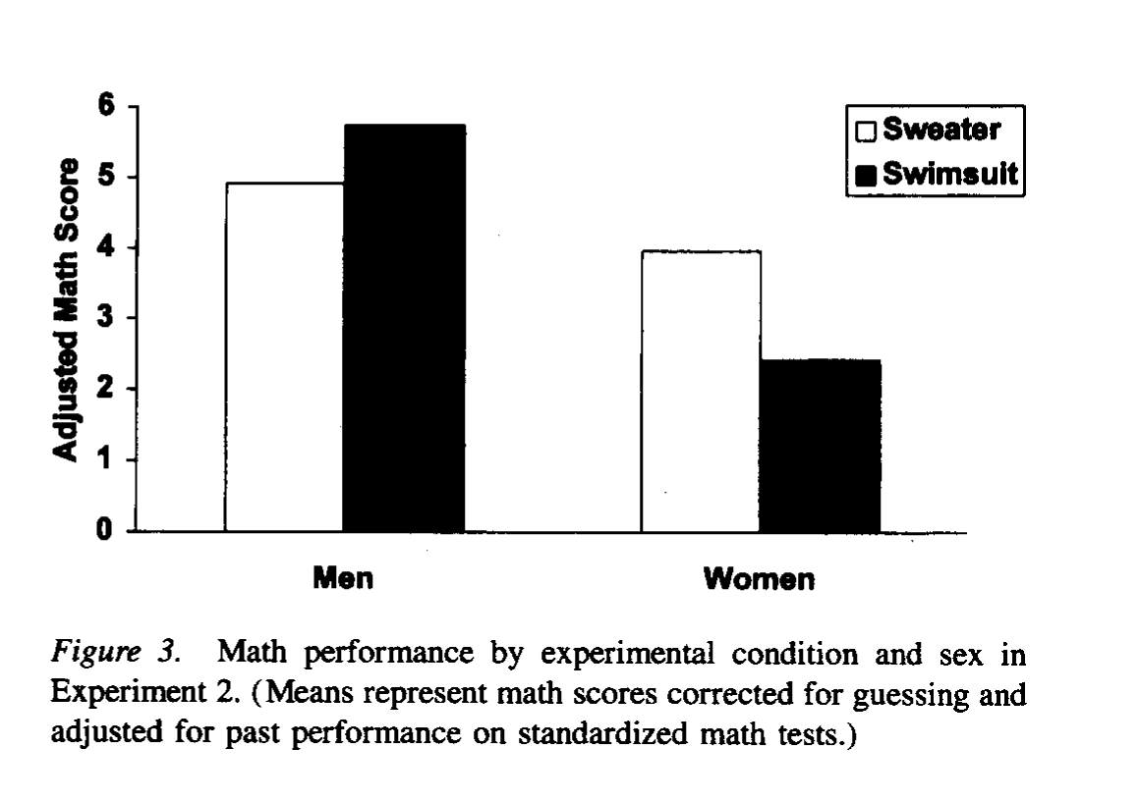
Figure 7: B Fredrickson et al “That Swimsuit Becomes You: Sex Differences in Self-Objectification, Restrained Eating, and Math Performance” 1988. Illustrative Diagram

When our bodies become the custodial property of the felt state of custody, its procedural body processes could have a more long lasting and profound psychological impact on females than on males and result in long-term trauma.
This is reflected in higher post release mortality rates amoung females than amoung males. (Graham 2003; Farrell and Marsden 2007).
This pervading gaze led me to consider constructing defensive attire against the machinery of the state apparatus that would create a habitus free from invasive hands and desires.
I designed a shift dress shape that would symbolize the derogative institutional attire that women have been clothed in within hospitals, prisons and the domestic sphere but constructed it with metal to symbolize armature (Figure 8).
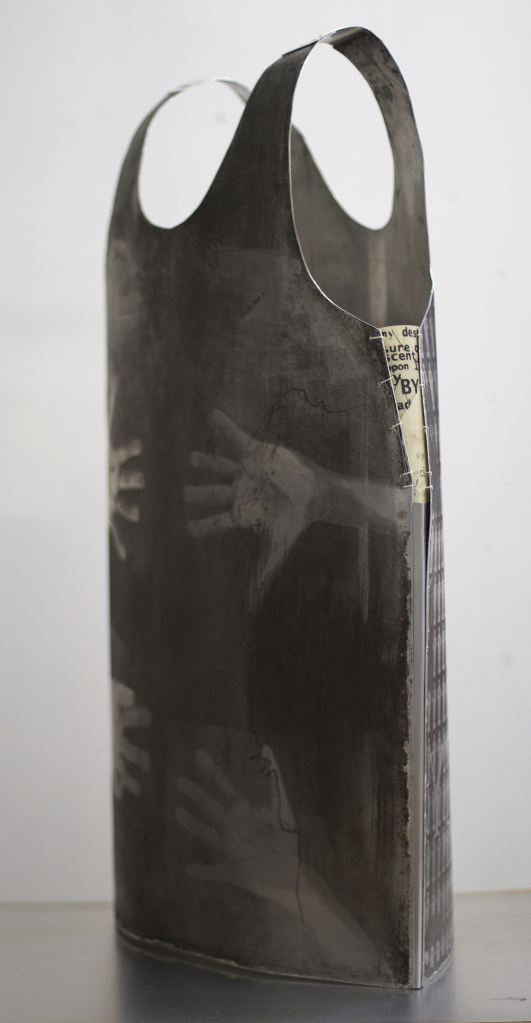
Figure 8: Carolyn Craig Your Hands On Me (shift element) 2013, etched aluminum, paper, wax, thread, hand riveted, dimensions variable

I inscribed it (using etching techniques) with the historicity of my life, with images of the hands that I felt invasively over me and the words that I felt define, confine and Other my actions and my subjective self.
I added text pieces onto mirrors that would sit under these suspended armour pieces. (Figure 9). These mirrors look up the skirts of the gendered female in homage to a wing ramp. During this ramp mirrors were placed under us as we were ordered to squat in order that officers could inspect our vaginas for contraband. The incident was also filmed (ostensibly as a record of their ethical behaviours).
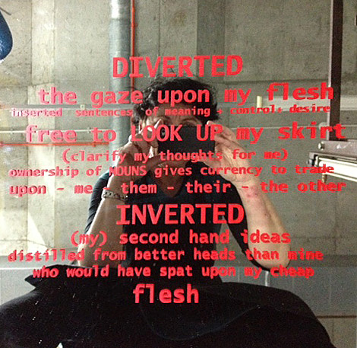
Figure 9: Carolyn Craig Your Hands on Me (mirror element) 2013, Mirror, screen-printed text, 60cm by 60cm

I have never reconciled or forgotten that absurd and degrading moment. It served little purpose in finding contraband but was a powerful instrument of coercion and an active reminder of the dominant visual gaze used as a mechanism of control by the state.
Following a random purchase of a second hand law book earlier this year I started to consider the judicial gaze. I define the judicial gaze as the full instrumentality of governance and legalistic devices sustained by the state and other institutions and validated by individuals who endorse its entrenched stereotypes and privileges.
These stereotypes constrain our narratives into silhouettes of moral decay, where the binaries of good and evil, black and white, privileged and lazy, justify the judicial gaze of judgment.
Within the Christian derived morality that frames our legal systems the female offender is still associated with sinfulness. Male offenders are often associated with the ‘ naughty boy’ phrase whilst female offenders are gifted with the not so useful “ deviant women “ or “filthy girl” judgment metaphors. It is within these linguistically entrenched metaphors that we are perceived as betraying the gender roles our patriarchal society projects upon us and forever casts us as fallen women.
A young male offender is much more likely to have his early crimes reconciled as
aberrant and daring youthful exuberance. A young female committing the same offence is tarred permanently as soiled and Othered to a much greater extent.
Artistic research within this idea has led me to explore the idea of the deviant woman as part of a broader analysis of gender power dynamics. This work forms part of a series called tomes of authority, which use the metonymic device of the book to consider the rules and regulations that coercively dominate and judge, (Figure 10).
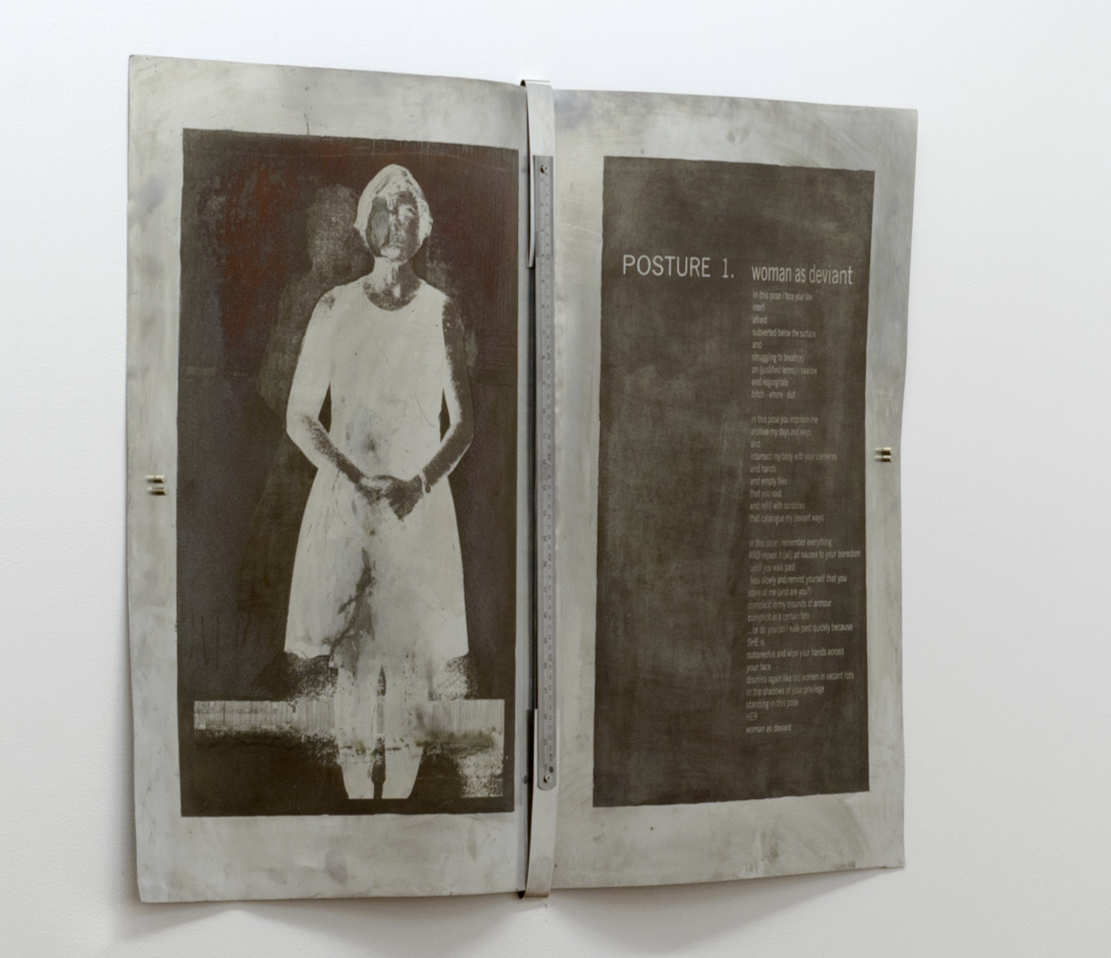
Figure 10: Carolyn Craig Tomes of Authority (Woman as Deviant) 2014, etched aluminium, metal ruler, text, 120cm by 70cm.

I have always revered and simultaneously feared books as symbolic realms that contain the imposed logic of normalizing frameworks. I associate them with the church, the school, the lawyer, and the indexical police record. But it has also
been in books that I have found inescapable means to new freedoms.
The image of the deviant woman also appears in a series of etchings that
examine the definitions of normalcy that exclude and sustain privileging regimes (Figure 11). In these I query the socially constructed systems of language and body comportment that regiment and regulate our everyday selves. This broader examination of the body in society expresses the underlying coercive frameworks that gendered females are subjected to. As a female offender, forms of social ostracism are pervasively amplified as we are subjected to constant exclusion and Othering post release in employment, housing, education and ongoing surveillance.
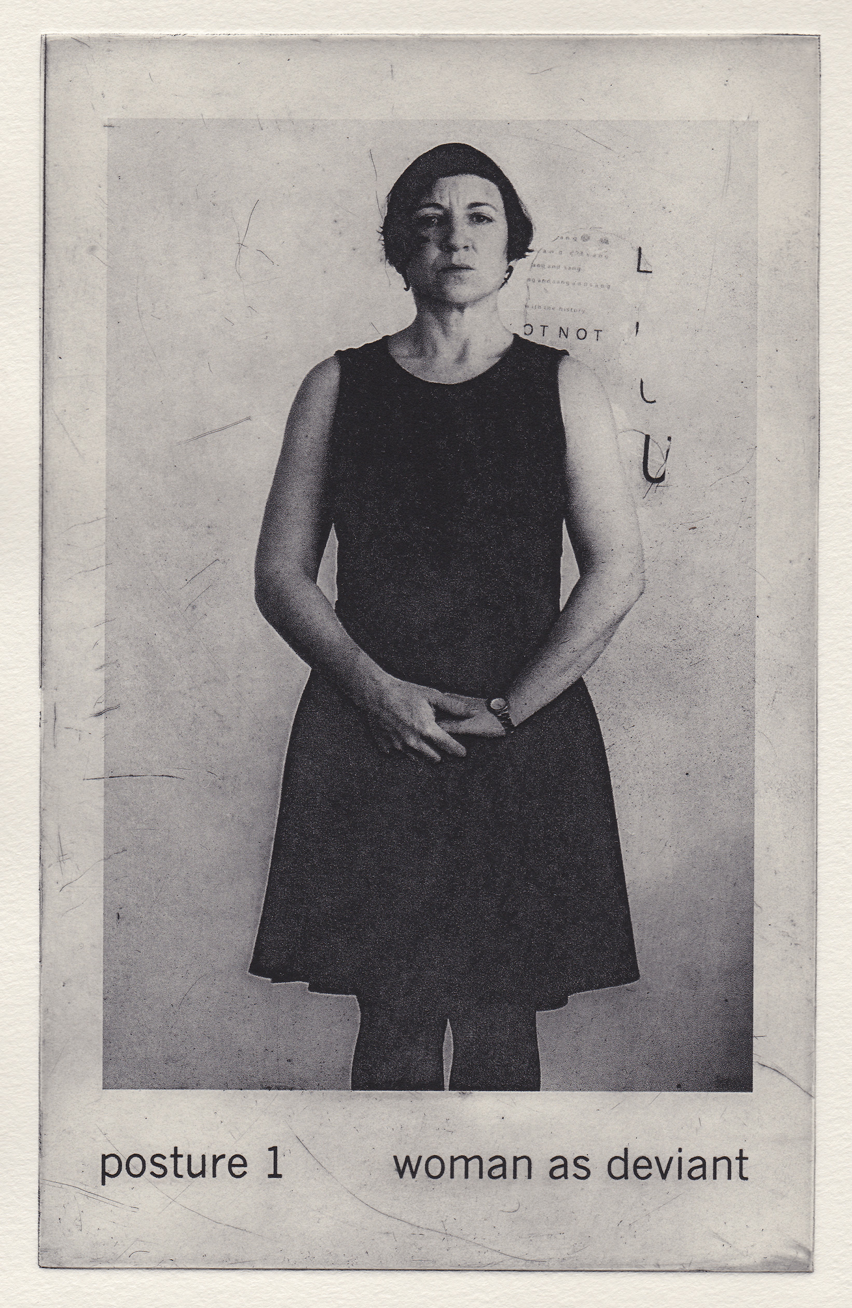
Figure 11: Carolyn Craig Posture 1:Woman as Deviant 2104, photopolymer etching, 20cm by 12cm.

This Othering circulates over the female body and becomes a continuation and
accentuation of the broader gender prejudges in society that treat a female body as an object. Within custody our bodies truly became an object. Warehoused by the state and subjected to psychological programming, social engineering and audited as bodies without inhabitants. Our bodies became an indexical trace without authorship.
Prison represents the dirty void that society endorses for the discarded bodies of those deemed unfit for the privileges of defined normalcy. As such those of us that understand its mechanisms and trauma should make visible our narratives of truth.

References
Baldry, Eileen. 1997. “Convicted Women:Before and After Prison”.Current Issues In Criminal Justice Volume 8 (March). 275-286, Sydney, W. Gaunt and Sons.
Baldry, Eileen. 2009.”Prisons, Institutions and Patriarchy”. Australian and New Zealand Critical Criminology Conference Proceedings, Monash University, Melbourne: 18-30.
Butler, Judith. 1988. "Performative Acts and Gender Constitution: An Essay in Phenomenology and Feminist Theory." Theatre Journal 40, no. 4 : 519-31.
Carlen,P and J Toombs.2006.”Reconfigurations of Penality:The Ongoing Case of the Women’s Imprisonment and Reintegration Industries”, Theoretical Criminology 10(3):337-360.
Carlen, P. 1998 Sledgehammer:Women’s Imprisonment at the Millennium.Basingstoke, UK:Palgrave Macmillan.
Carlen, P. 1983 “Toward a Radical Understanding of Trauma and Trauma Work”, Violence Against Women 9(11):1293-1317.
Carlton, Bree and Marie Segrave 2011 “Women’s Survival Post-Imprisonment :Connecting Imprisonment with Pains Past and Present”, Punishment and Society 13(5): 551-570. Sage Publications accessed March 2014 doi 10.1177/1462474511422174
Bentham, Jeremy. 1791. Panopticon or the Inspection House. London: T Payne.
Davidson, Janet. 2009 .Female offenders and risk assessment:Hidden in plain sight .El Paso, Texas, USA, LFB Scholarly Publishing .
Farrell, M and J. Marsden,. 2007.”Acute risk of drug-related death amoung newly releases prisoners in England and Wales”. Addiction 103(2):251-255.London, UK, Society for the Study of Addiction.
Fredrickson, B et al 1998 “ That Swimsuit that Becomes You:Sex Differences in Self-Objectification , Restrained Eating, and Math Performance”, Journal of Personality and Social Psychology 75 (1):269-284.
Foucault, Michel. 1975.The Birth of the Clinic: An Archaeology of Medical Perception. New York: Vintage Books.
Foucault, Michel, 1979.Discipline and Punish: The Birth of the Prison. New York; Harmondsworth: Penguin.
Foucault, Michel.1974. The Order of Things: An Archaeology of the Human
Sciences. London, England: Tavistock .
Graham, A. 2003 “Post-Prison Mortality:Unnatural Death Amoung People Released from Victorian Prisons between january 1990 and December 1999”, Australian and New Zealand Journal of Criminology 36(1):94-108.

